Image Processing and Learning Methods

Assign 4–Learning Methods

Due: 11:30 p.m. Friday, April 30th, 2021 (Cleveland Time)

***Please write your solution in the WORD document or on hand-written papers, then submit it to the Blackboard system.* 100 points as the full score + 15 bonus points.**

**1. [25 points]** Suppose you have two outputs of CNN: P= [9/25, 12/25, 4/25, 1/8, 1/10], Q= [1/5, 1/6, 1/5, 1/8, 1/5]. Which one has higher uncertainty based on the definition of entropy? Please show your computation in detail.

**Ans:**

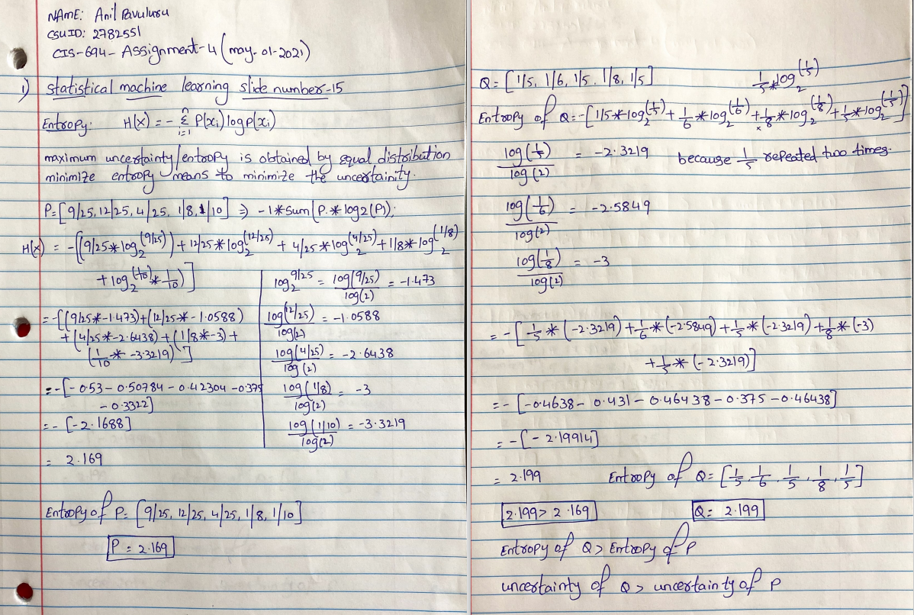

**2. [25 points]** There is a training set of two classes. Each of them contains some training samples as follows:

Class1 = [1, 2, 3, 4, 5, 6, 7, 8, 9, 10]

Class2 = [-2, 5.5, 6.1, 5.2, 5.1, 5, 5, 6, 5, 7.3, 5.9, 5.8, 5.1]

Given a new testing sample X=6, which class does it belong to using the Bayes Maximum a Posteriori (MAP) classifier? Please show your computation in detail.

Ans:

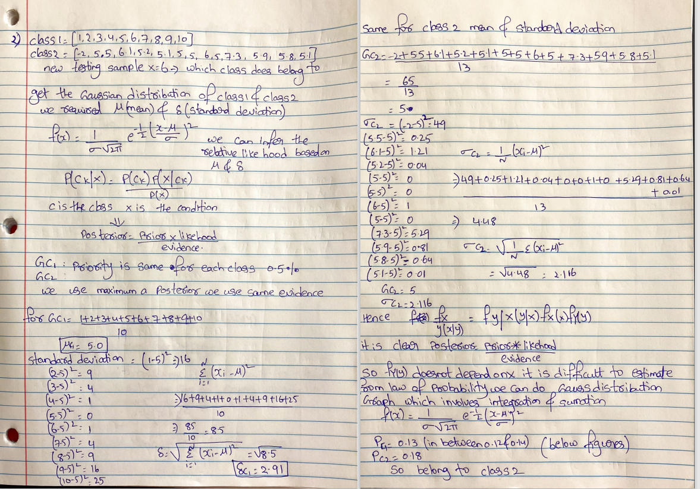

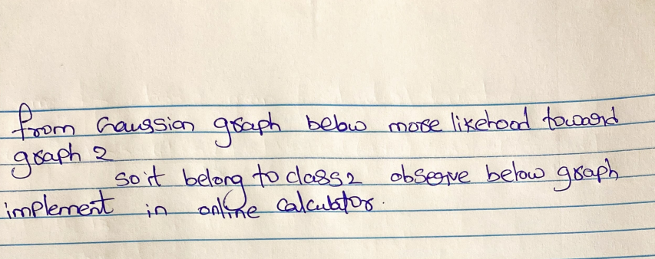

Gaussain distrubtion for class-1 graph

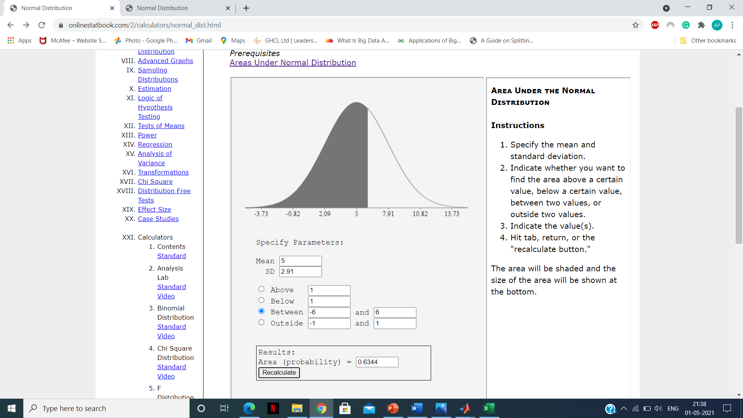

Gaussaindistrubution Graph for class-2

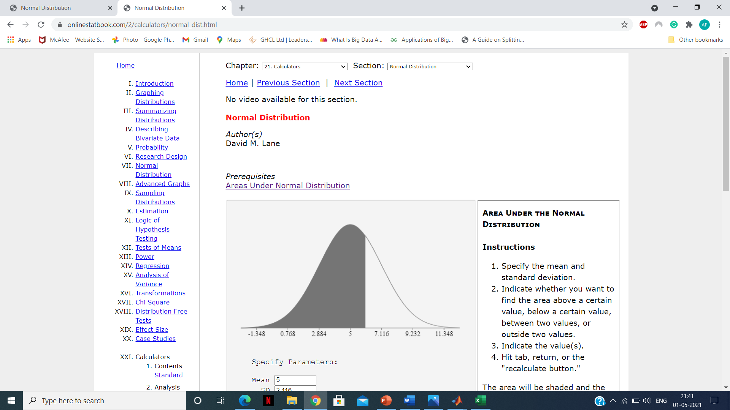

**While based on discussion of lab-8 in class 1&2 changed data and implemented here I got graph for probability distribution, so I have got posterior graph so more peak at class-2 like that I decided**

**Code**

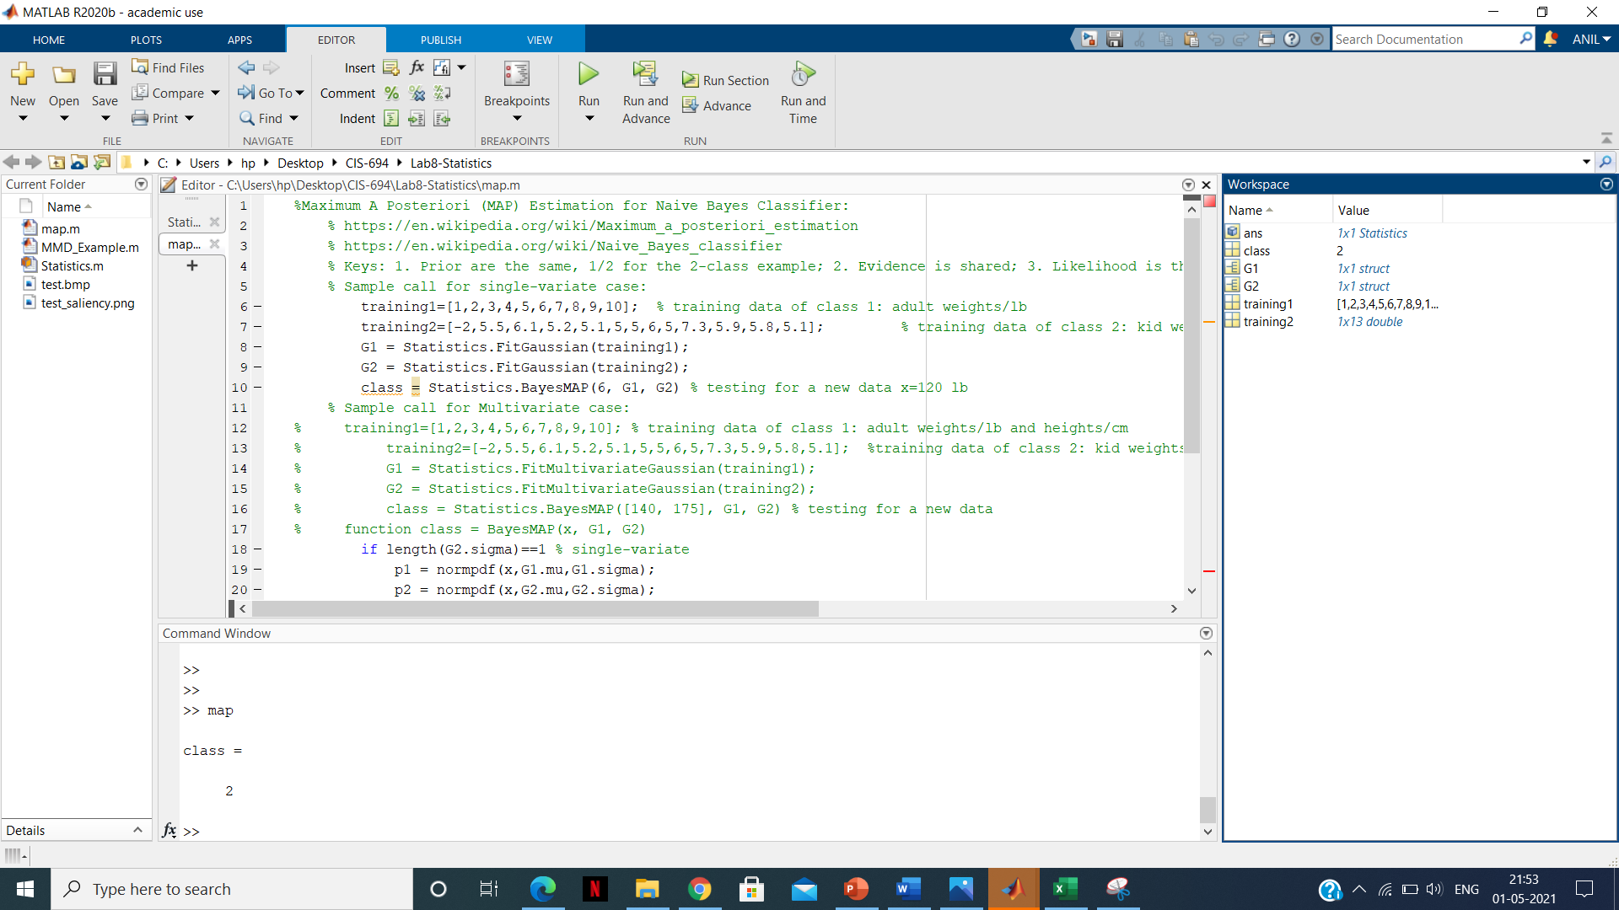

**For class-1**

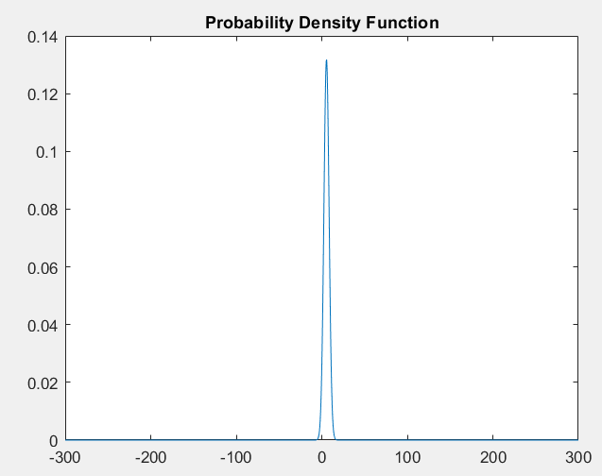

**For class-2**

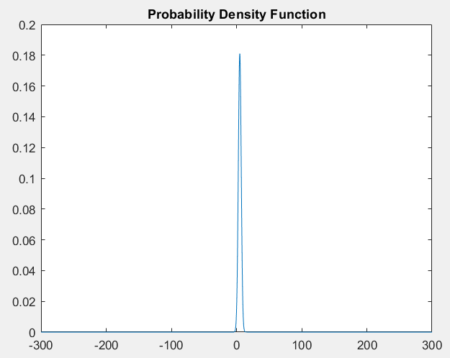

**3. [25 points]** Suppose two distributions: P = [9/25, 12/25, 4/25, 1/8, 1/10], Q = [1/5, 1/5, 1/5, 1/5, 1/5]. What are results of the KL Divergence(P, Q) and KL Divergence(Q, P)? Please show your computation in detail.

**Ans:**

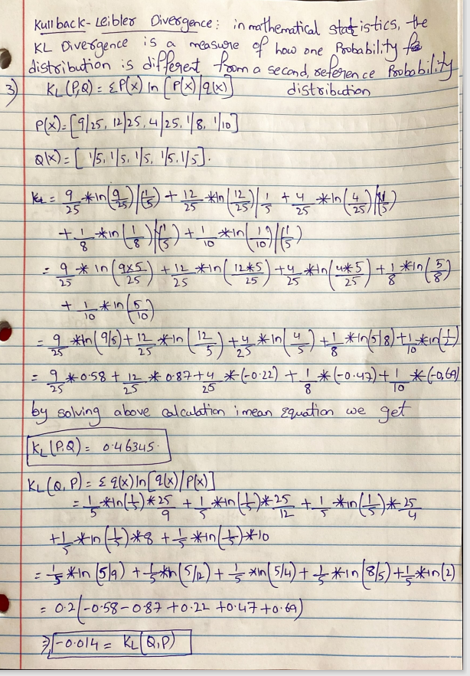

**4. [25 points]** Suppose you are doing a classification task of 4 classes via CNN, before the Softmax normalization, your output of one training sample for the class 0, 1, 2, 3 are 7.0, 4.1, 8.5, -2, respectively. The ground truth of this training sample is class 0. What is the cross-entropy loss for this training sample? Please show the detailed intermediate computation steps.

**Ans:**

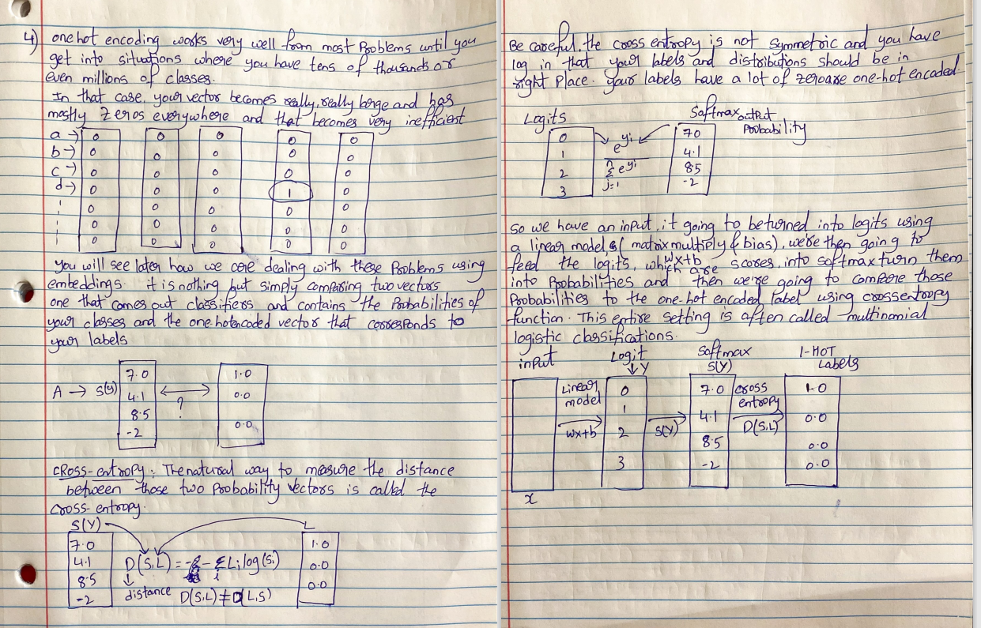

**5. [15 bonus points]** Given the following feature map of one CNN layer, if we apply a sum pooling with 2x2 filters and stride 2. What will be the sum pooling result? What will be the result if we only change the pooling method to average pooling?

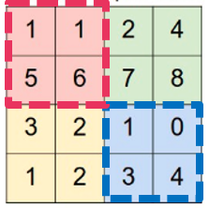

**Ans:**

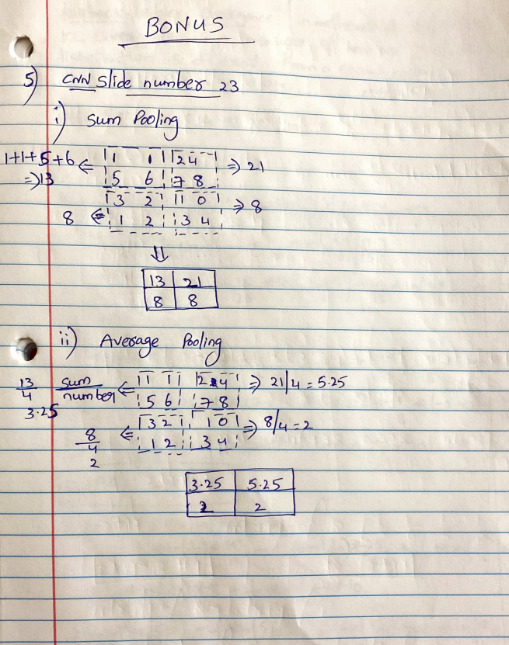

Note: Assignment-4 Answers are like supporting document handwritten solution file.that’s why I zipped two files so you can clearly understand for time saving